Name Surname: Furkan Özer Date:05/12/2025
Number:2023555067 Report No:06
Digital Design Lab Report
Homework / Lab
Parts of Report:
- Description: Design an 8-bit register with synchronous reset, load control, and rotate-right operation.

- Turth Table of Design

RESET | LOAD | ACTION | REG NEXT ST.
1 | X | Reset | 0
0 | 1 | Parallel Load | din
0 | 0 | Rotate Right | Reg(0)& Reg(1 to 7)

- Drawing the circuit of desired desing

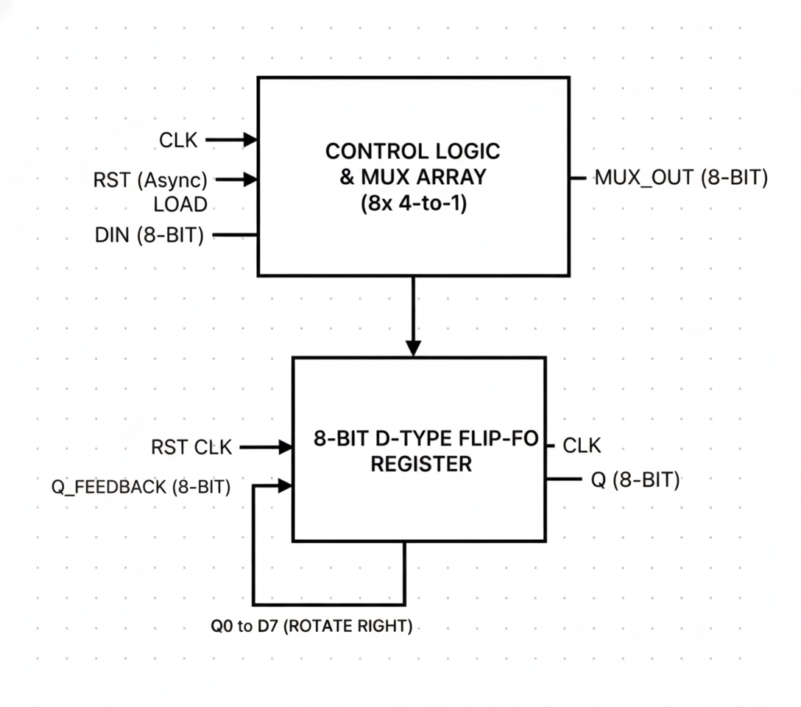
- Steps of Lab/Homework:

library IEEE;
use IEEE.std_logic_1164.all;

entity sgate is
port(
clk : in std_logic;
rst : in std_logic;
load : in std_logic;
din : in std_logic_vector(7 downto 0);
q : out std_logic_vector(7 downto 0)
);
end entity sgate;

architecture rtl of sgate is
signal reg : std_logic_vector(7 downto 0);
begin
process(clk)
begin
if rising_edge(clk) then
if (rst = '1') then
reg <= (others => '0');
elsif (load = '1') then
reg <= din;
else
reg <= reg(0) & reg(7 downto 1);
end if; -- biten iç if (rst / load / else)
end if; -- biten rising_edge if
end process;

q <= reg;

end architecture rtl;

Simulation Results:

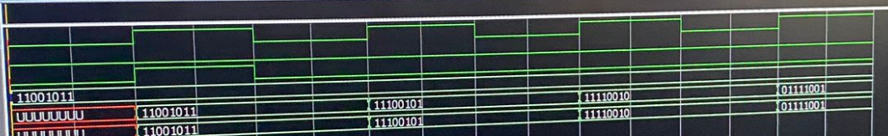

Conclusion: The developed 8-bit register module, named sgate, operates in synchronization with the clock signal. The circuit's priority control structure ensures that the RST input clears all outputs first. In the absence of a reset condition, the circuit uses the LOAD signal to perform a parallel update with the DIN data. When neither of the higher-priority commands is active, the register maintains its contents in a circular right shift mode. The simulation results clearly validate this sequential behavior and confirm the successful verification of the designed multi-modal operations.

